1)

A. The screenshot below shows that the rank for the two matrices is the same which is equal to 3. This proves the existence of solution for the given solution.

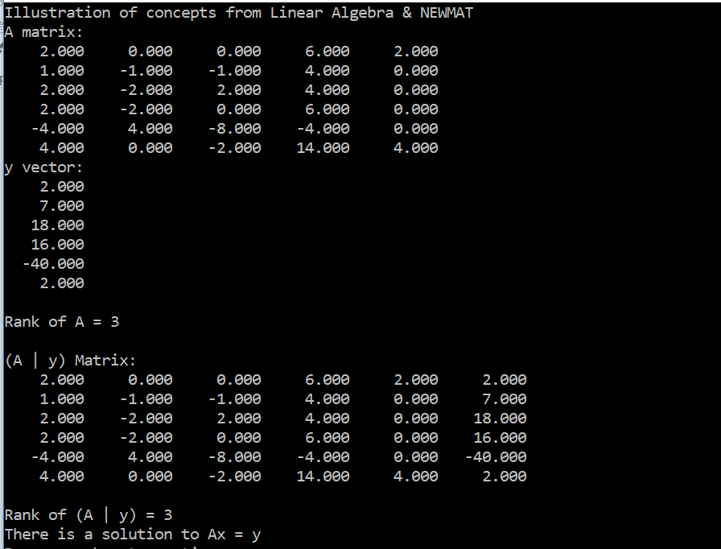

B. The screenshot obtained below shows the solution obtained. There “5 choose “ = 10 number of solutions. Out of these 10 possible solutions, eight of them are basic feasible for the given set of solutions. The rank of the matrix is 3, therefore, only 3 of these eight solutions are required. By Trial and error, solutions 1, 2 and 10 are the required solutions.

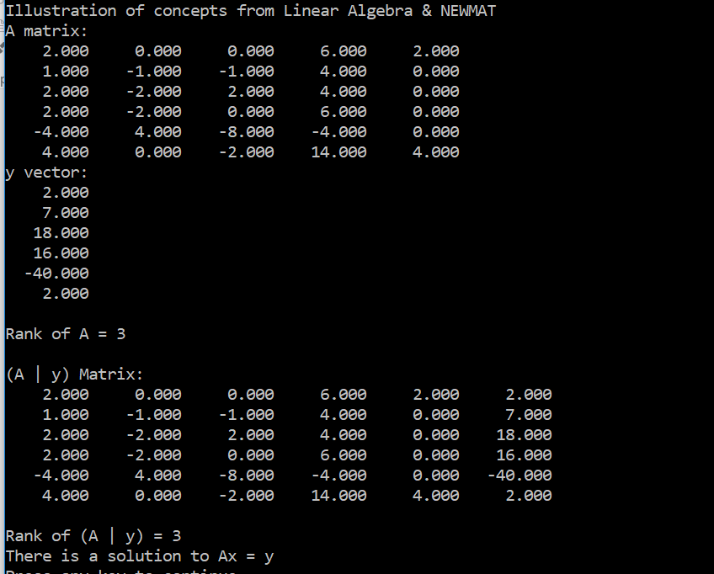

Taking the affine combination, we get

$$λ1\left[\begin{matrix} 1 \\ -7 \\ 1 \\ 0 \\ 0 \end{matrix} \right]+ λ2\left[\begin{matrix} 4 \\ -7 \\ 0 \\ -1 \\ 0\end{matrix}\right]+(1-λ1-λ2)\left[\begin{matrix} 0 \\ -8 \\ 1 \\ 0 \\ 1\end{matrix}\right]=\left[\begin{matrix}λ1+4λ2 \\ λ1+λ2-8 \\ 1-λ2 \\ -λ2 \\ 1-λ1-λ2\end{matrix}\right]$$

C. The following snippet of code was executed on MATLAB

A = [2 0 0 6 2;1 -1 -1 4 0 ;2 -2 2 4 0 ; 2 -2 0 6 0; -4 4 -8 -4 0;4 0 -2 14 4];

s1=sym('s1');

s2=sym('s2');

B= [s1+4\*s2;s1+s2-8;1-s2;-s2;1-s1-s2];

C=A\*B

The Output obtained is 2 7 18 16 -40 2

The screenshot below shows the same

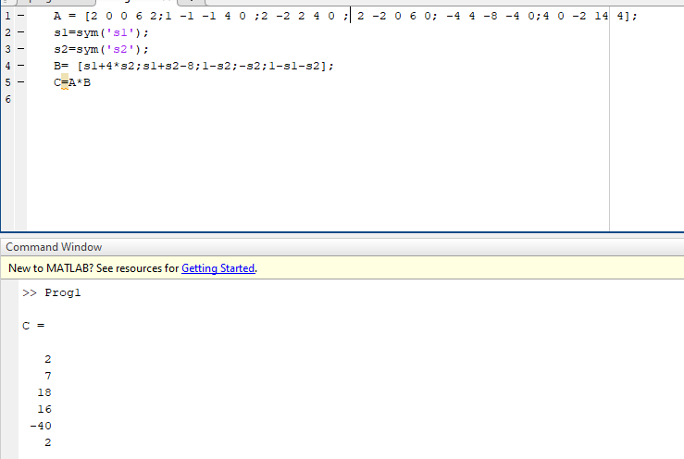

D. The screenshot below shows the computation for the same on MATLAB

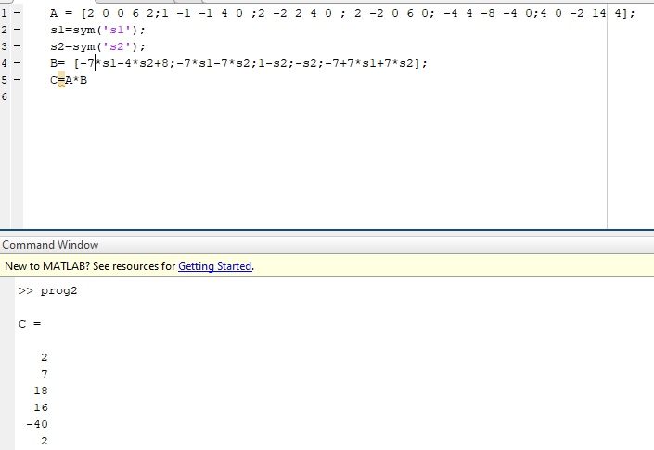

E. The screenshot below shows the rank for the constrains that are added together. It can be shown that the new system will have 5 linearly dependent columns which will be equal to the number of columns in A. Therefore, adding two constraints doesn’t change the set of solutions.

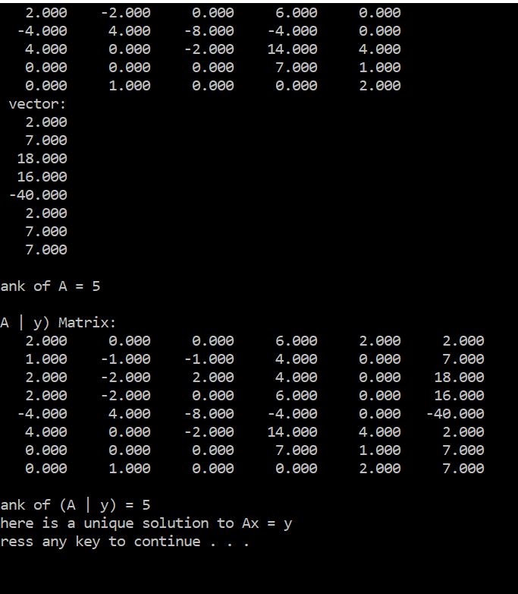

3. D. The algorithm is valid for n=3 and 4.

